<http://cvm-889.techmahindra.com/cqweb/oslc/repo/8.0.1/discovery>

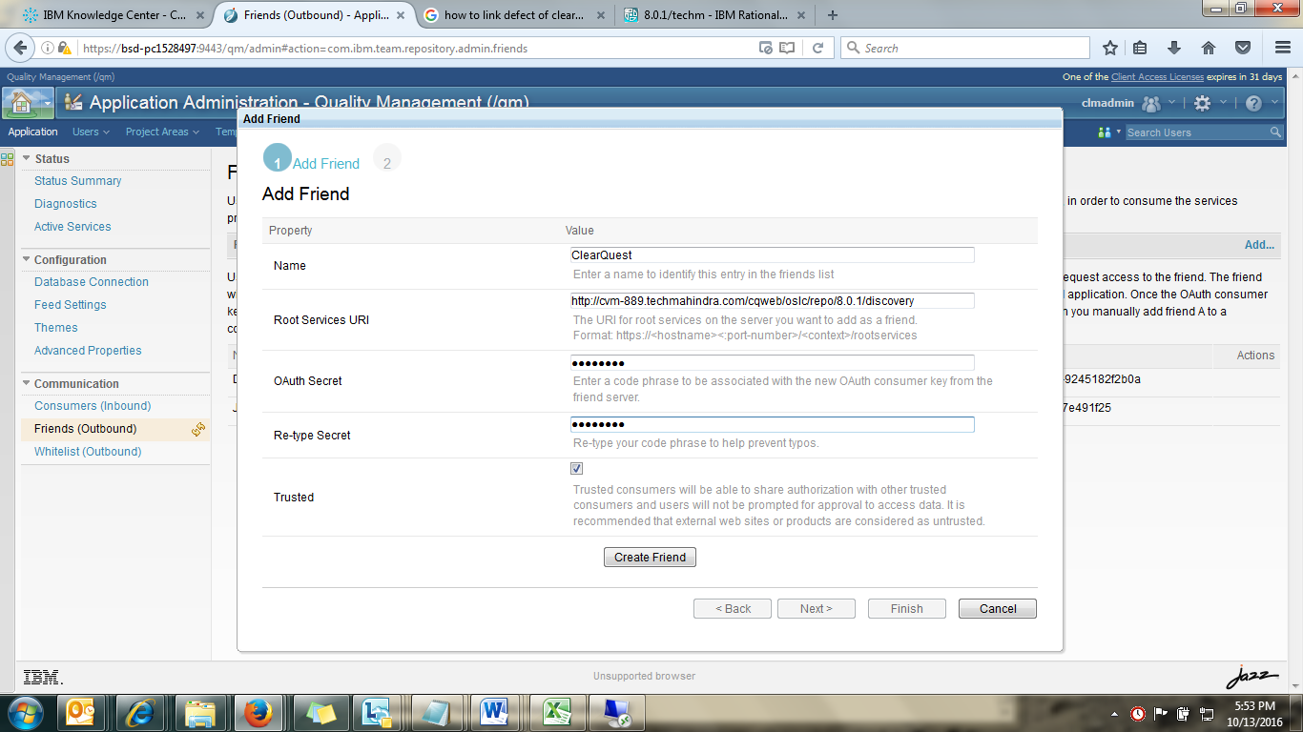

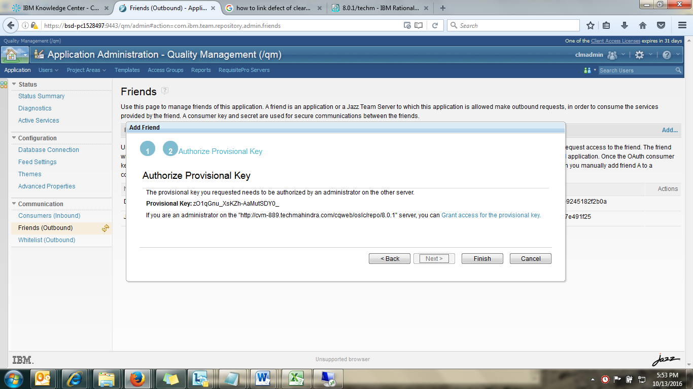

The provisional key you requested needs to be authorized by an administrator on the other server.

**Provisional Key:** zO1qGnu_XsKZh-AaMutSDY0_

If you are an administrator on the "http://cvm-889.techmahindra.com/cqweb/oslc/repo/8.0.1" server, you can Grant access for the provisional key.

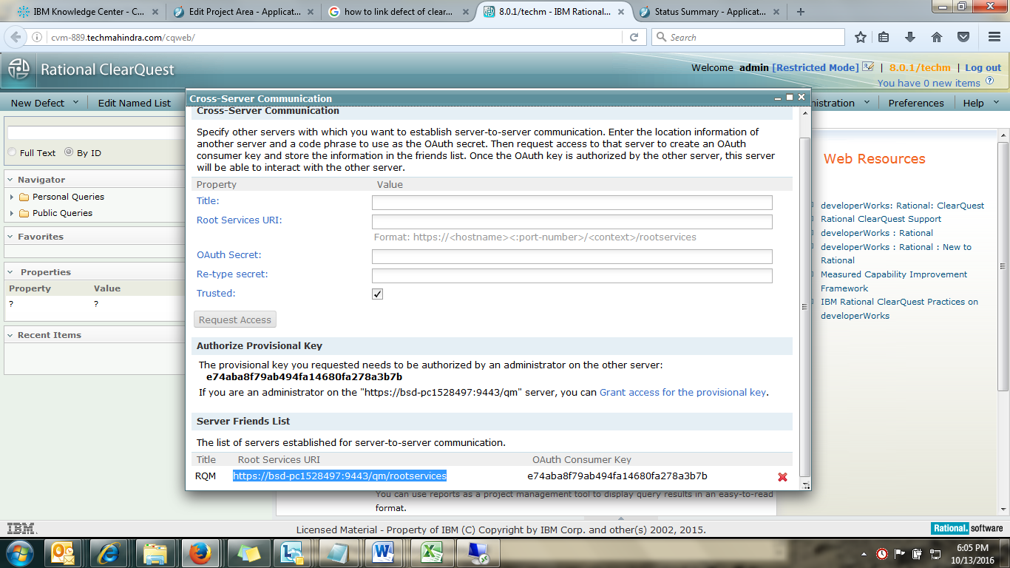

|  |  |
| --- | --- |
|  | https://bsd-pc1528497:9443/qm/rootservices |

